ARRANGING SERIES OF NUMBERS BY IMPLEMENTING HEAP SORT

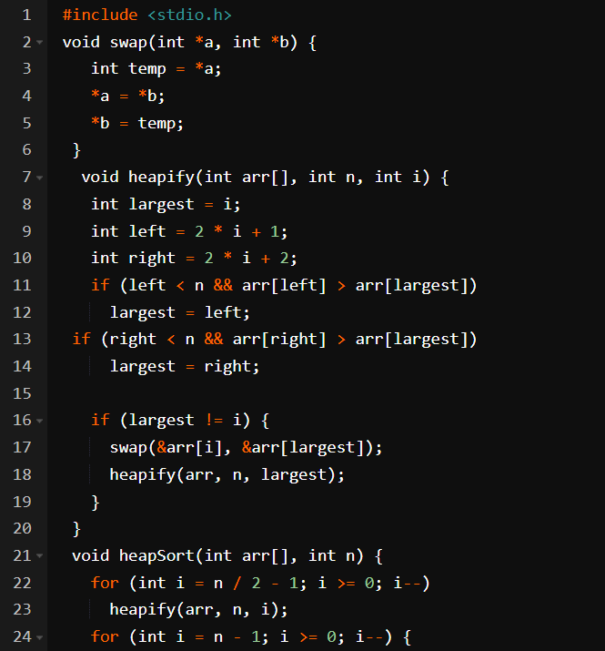

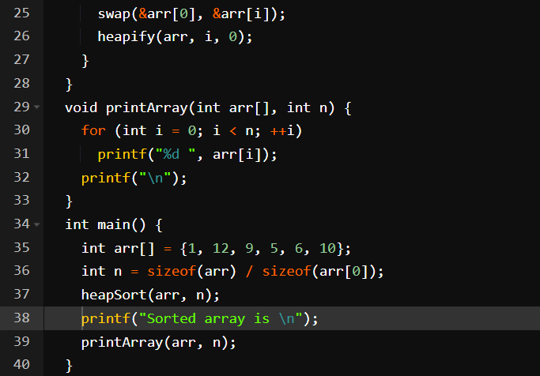

OUTPUT:

